**Nog, Son of Rom**

First Ferengi in Starfleet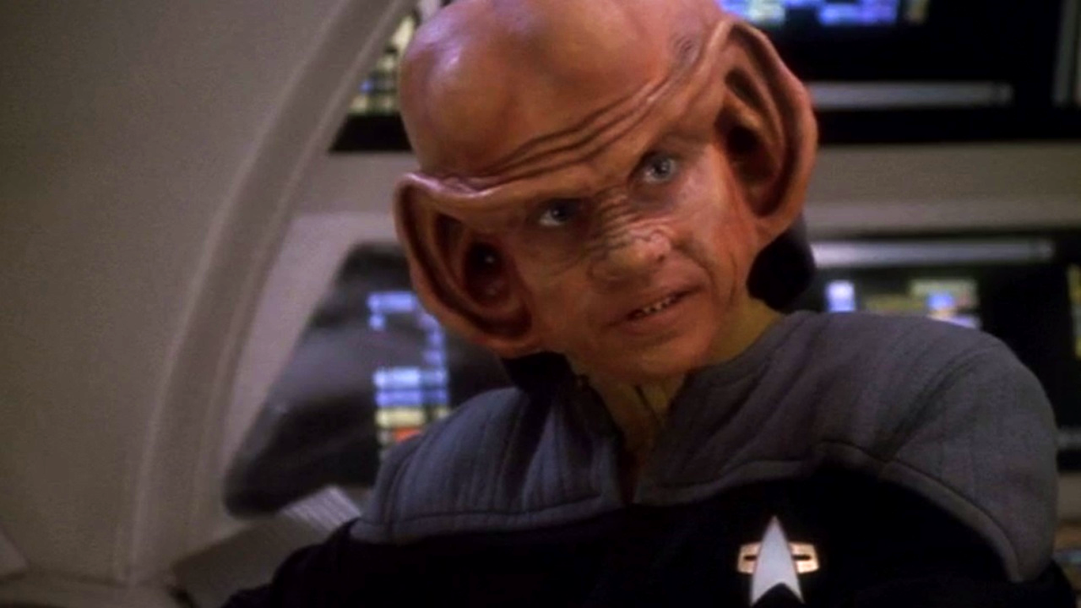

*Nog was promoted to Ensign after just two years in Starfleet Academy. Here is Nog, smiling, in his ensign uniform.*

### **From Jake's partner in crime to decorated Starfleet officer.**

**IN THE BEGINNING:** Helping out at his uncle, Quark's, bar is how Nog spent most of his time. He was a traditional Ferengi - profit was the only goal in life, and HU-mons were to be avoided when possible. When the Cardassians left Terok Nor, what became Deep Space Nine, it created an influx of Federation citizens and adventurers to the station and Quark’s Bar.

Nog became friends with young Jake Sisko, the son of the new station commander. They spent their time goofing off and getting into mischief. Nog’s friendship with Jake exposed him to Starfleet personnel on a regular basis. Nog learned more about humans, and started going to the station school despite his father, Rom’s, warning him to stay away from the Federation and HU-mons.

**A BOLD CHOICE:** Despite his family’s animosity toward the Federation, Nog decided to apply for the Starfleet academy. Commander Sisko put Nog through a series of tests to gauge whether Nog was serious. Sisko saw how dedicated Nog was and personally recommended him for the academy.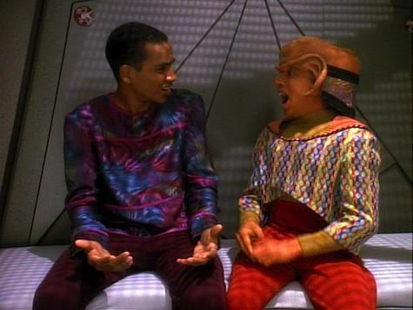

While at the academy, Nog is drafted to help Benjamin Sisko during an attack on Earth that is a part of an attempted coup to undermine the Federation president.

His sophomore year, Nog returned to Deep Space Nine and roomed with Jake. But being roommates almost ended their friendship because of their similarity, conflicting personal habits. Nog and Jake clashed and ended up in the brig on trumped-up charges, so the boys' were forced to mend their friendship.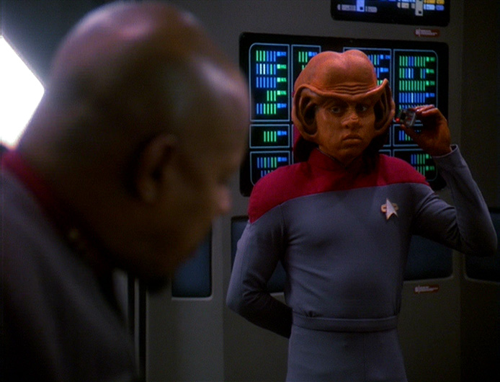

**FIRST FERENGI IN STARFLEET**: As a cadet, Nog was thrust into the thick of things as the Dominion War was raging. Commander Sisko trusted Nog and relied on his unique skills during many missions. Nog used his acute hearing to relay messages between engineering and the bridge when the communications were down on the Defiant. At one point, Nog's Ferengi know-how came in handy when he was able to get a vital piece of equipment for the Defiant by making a number of backroom deals.

When the Cardassians join the Dominion and retook Terok Nor/Deep Space Nine, Nog had to leave his family behind on the station and fight with Starfleet. At one point, the Defiant lost communications and Nog, with his superior hearing, acted as a living intercom.

**THE FOG OF WAR:** Nog got promoted to ensign and was a regular crew member of the Defiant. On a mission to resupply the solders protecting a recently captured Dominion communication array, Nog was asked, once again, to use his acute hearing to scout for Jem'Hadar solders approaching their position while the team defended their position. The ensign was shot when his scouting party got cut off from their escape route. Nog was injured and lost his leg.

To keep up morale during the tense wait for the Jem'Hadar to attack, Julian played “I’ll be seeing you” from a recording by the holosuite character Vic Fontaine. As Nog laid there hurt and barely conscious, he heard the haunting music juxtaposed with his friends fighting, and dying, to defend their position.

While Nog got a biosynthetic leg and returned to the station to recuperate, he suffered from severe PTSD. Nog insisted on using a cane, even though the doctors said he was completely healed. Nog's loved ones were worried he wouldn’t mentally recover and tried different things to cheer him up, only to push him farther into his depression.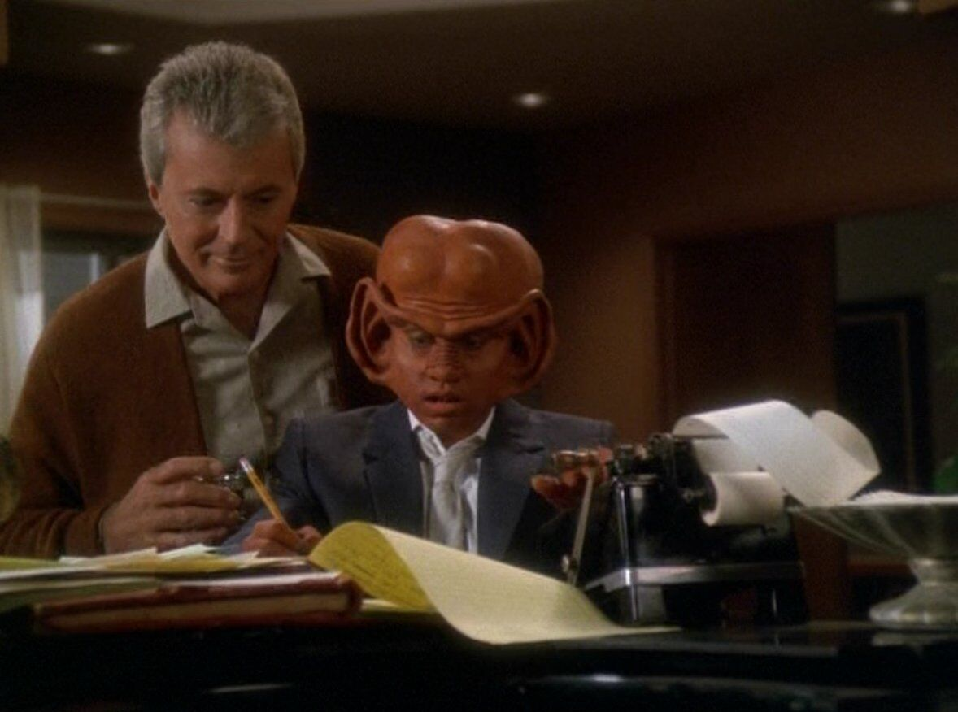

Finally, Nog went to the holosuite to ask the hologram, Vic Fontaine, to sing "I'll Be Seeing You" for him. Vic sung the song in every way he could think of. Finally, Nog asked Vic if he could stay with him in his holographic apartment.

Vic humored Nog and took him under his wing, letting him help in the holosuite club. Nog got into a groove in the club, donning a tux and helping customers. Eventually, Nog gained his confidence back and forgot to use his cane.

Nog seemed ready to leave the holosuite and go back to his family and friends, but he tells Vic he wants to stay there forever. When Vic asks why, Nog tells him it’s because after being injured, he realized that he could die out there in the real world. Vic told Nog he would die slowly in the holographic world and fade away if he didn’t face his life. He reminded Nog that everyone dies, but it’s how you lived that is important.

Nog realized Vic was right and returned to his life and his grateful family. Once completely healed, Nog was once again a crew member of the Defiant fighting to defeat the Dominion. After the war, he stayed on with Deep Space Nine under Kira's command. Nog was promoted to lieutenant junior grade by Sisko's as one of his last acts as commander.

Nog proved over and over again that he had heart: from a busboy to a war hero.

*"You've got to play the cards life deals you. Sometimes you win, sometimes you lose. But at least you're in the game."*

*-- Vic Fontaine*

Here's the [Memory Alpha](https://memory-alpha.fandom.com/wiki/Nog) entry for Nog because I know you are going to want to know more.

Also, please check out Aron Eisenberg's [obituary](https://www.startrek.com/news/aron-eisenberg-obituary-star-trek) on Startrek.com. Aron Eisenberg died in September 2019, at age 50. He was the heart of Nog's character, and he will be sorely missed.

